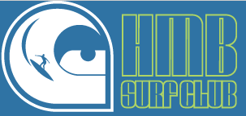
Half Moon Bay Surf Club
An affiliate of the Boys and Girls Club of the Coastside
535 Kelly Avenue, Half Moon Bay, CA 94019
Tax ID #94-3193725

Summer 2014

Dear Local Business Owner,

The Half Moon Bay Surf Club, an affiliate of the Boys & Girls Club of the Coastside, will be hosting its annual Surf Luau fundraiser on Saturday, September 20th, and would like to ask for your support in the way of a donation for our raffle or silent auction.

This event is widely recognized in the coastal community with over 300 in attendance. It’s also our sole fundraiser! All proceeds fund surf equipment, league & team fees (+ so much more) for the 2014-2015 season, supporting both the High School and Middle School.

The HMB Surf Club’s mission is to encourage kids of the coastside to surf, work hard in school, and develop a greater respect for the ocean and those we share it with.

We hope that you will consider supporting our program! All donations are tax deductible.

Mahalo,
Maria King, 2014 Surf Luau Co-Chair
hmbsurfluau@gmail.com | 650.922.3703

Please complete the information below:

Donor Name:
Address:
Phone:
E-mail:
Item Description:
Item Value:

Please return the above info + your donation to (or contact for pick-up): Maria King, 80 Redwood Terrace Rd, Woodside, CA 94062 | hmbsurfluau@gmail.com or 650.922.3703

